# **GNOSIS BOMB |**

.As Above, So Below.



A board and card game hybrid where the players must either attain a gnosis, or knowledge bomb, or have the most negative or positive karma at the end of the game. It’s light vs dark; and the stakes have never been higher.

## 

## 

## 

**Game Designer: Datorien Anderson**



## Table Of Contents

**GNOSIS BOMB |** **1**

Table Of Contents 2

Game Description 3

Number of Players 3

GRATIS Outline 4

Goals 4

Rules 4

Actions 4

Transitions 5

Items 5

Setup 5

Meaningful Action Analysis (MAA) 6

Card Game Table Layout Diagram 7

Scenarios & Primers 9

Locations: 12

Karma Points 14

Point System 14

Karma Tiers 14

Event Cards 16

Report Summary 17

Flowchart(s) & Storyboards 18

Component Pieces 19

Cards 19

Items 20

Other Ways to Play (IGNORE THIS AND EVERYTHING BELOW) 21

Developers Log **22**

## 

## 

## 

## **Game Description**

Players take turns gaining or losing karma. They must reach a set number of points to gain a lesser card. It’s best three out of four, or similar rounds such as that, in a set game. There are three card colors: two of which are assigned point values and the other are chance cards to add procedure to the game.

The game page for the companion app can be found here once finished:

<https://voidespy.itch.io/gnosis-helper>

### **Number of Players**

* 2-8 Players
* Ages 14+

### 

### **GRATIS Outline**

#### Goals

* Have the most negative or positive points in a round.
* To do enough evil or good deeds to summon a Lord of Hell or Arch-Angel.
* Getting a karma bomb instantly wins the game.
* Overtake a scenario.

#### 

#### Rules

* A fixed amount of points reached gains an instant karma-bomb thus winning the round.
* The Architect chooses how many points.
* Can’t instantly do terrible or miraculous deeds.
* Assigned point values are integers of five unless stated otherwise by a grey card.
* Grey cards exist to remove, add as well as add challenges to the game.
* Grey cards are shuffled, three are placed and only one is picked.
* Once one is chosen, the other two will go to the bottom of the deck.
* Only two grey cards can be skipped in each round.
* Dice rolls for execution of how well the plan goes--if the dice sum is above a certain number, then there is a critical.
* At the end of every round, the losing team gets to pick a grey card.
* Discard pile goes in the center.
* The first to gain a lesser card gains fifty starting points.
* Gaining a lesser card means doing a different tier deed.
* If a team has a lesser card and the other time gets a karma-bomb, they lose their lesser card.
* Good needs to stay neutral or positive.
* Bad needs to stay neutral or evil.

#### Actions

* Shuffle
* Deal
* Draw
* Skip
* Discuss
* Assign

#### 

#### Transitions

* Start Game
* Draw
* Discard
* Think
* End Game
* Primer

#### Items

* Coin
* Die (?)
* 13 Lords of Hell Cards
* 13 Angels Cards
* 7 Lesser Demons Cards
* 7 Lesser Angels Cards
* 3 Tier Charts
* Primer/Scenario Cards
* Location Cards
* Event Cards
  + Black Cards (Dark Aligned)
  + White Cards (Light Aligned)
  + Grey Cards (Neutral Aligned)

#### Setup

* Unpack cards
* Shuffle cards
* Place cards on board or table
* Place Tier Charts
* Place discard pile
* Flip a coin to decide who goes first
* Start game
* Select a Primer
* Roll, Assign & Reflect -> Action -> Scenario
* End Round then Start a new: Primer; RAR -> Action -> Scenario

#### 

## Meaningful Action Analysis (MAA)

Analysis of the meaningful and unmeaningful actions that the player will be able to take during the standard gameplay loop.

These are:

* Shuffle - Rearrange cards. Not meaningful, involuntary action
* Affect - The Lesser Angel & Demon cards will have an effect on gameplay; Lords & Archangels allow for different types of things to happen as well as mulligans and sabotage.
* Deal - distribute cards in rotation or wildly for a game or round. Not meaningful, it is an involuntary action.
* Draw - draw a card from one of the three cards, not meaningful, this is an involuntary action.
* Skip - Can skip a grey card. There is a limit to doing so. Not meaningful, the player gets to choose between two random grey cards.
* Discuss - Players will discuss what actions they want to do to stop the other team and accrue points. This is a meaningful action that should take up the bulk of the game.
* Assign - Points are added up after the end of round to determine round winner. Not meaningful, it is an involuntary action. Certain point assignments are dependent on the results of the discussion action.

#### 

#### 

## Card Game Table Layout Diagram

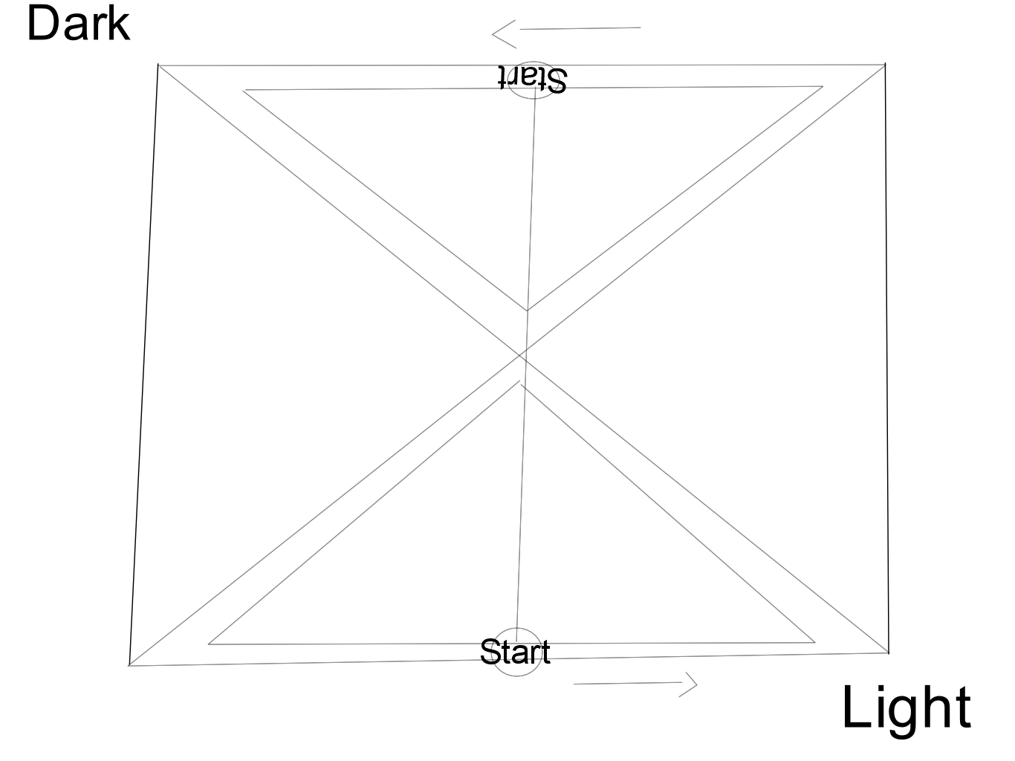

*(A sketch of the first board prototype: Ideally, the writings would be gold. The board should match the colors of the card back but also have purple spaces for the cards to be placed.)*

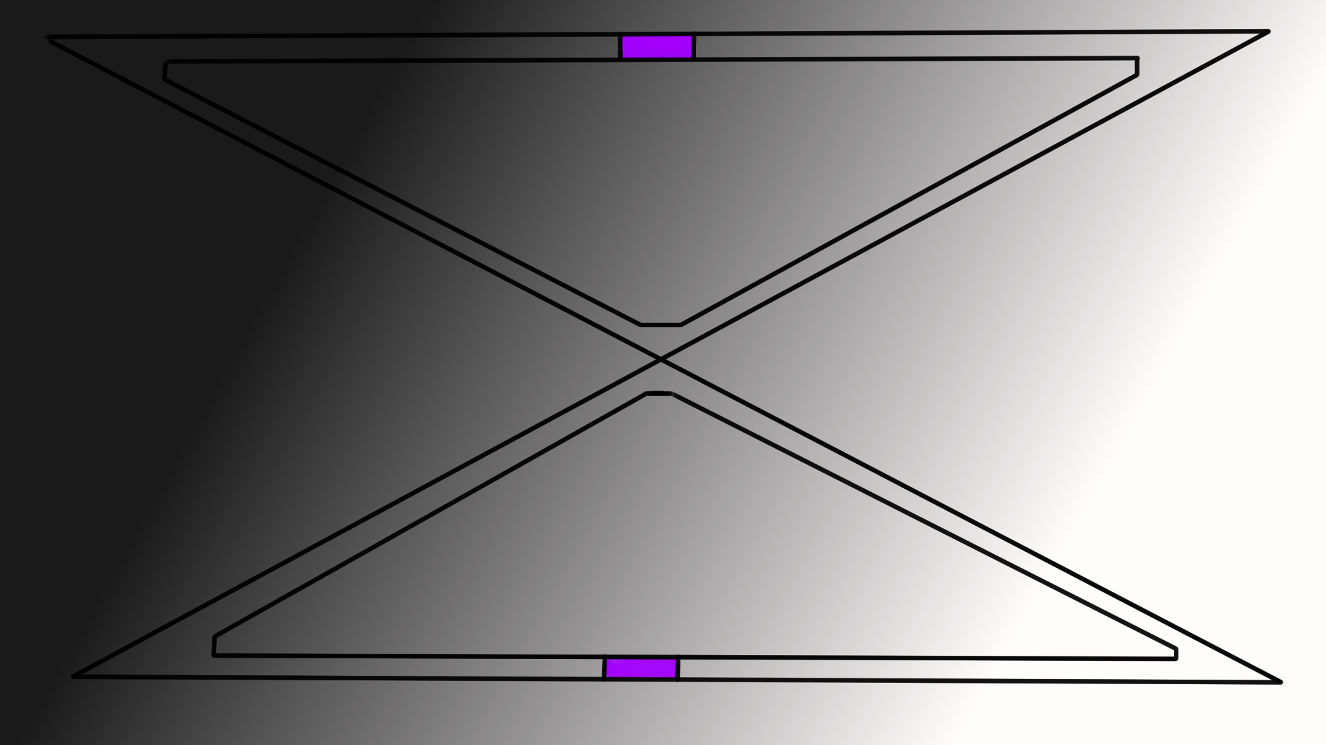

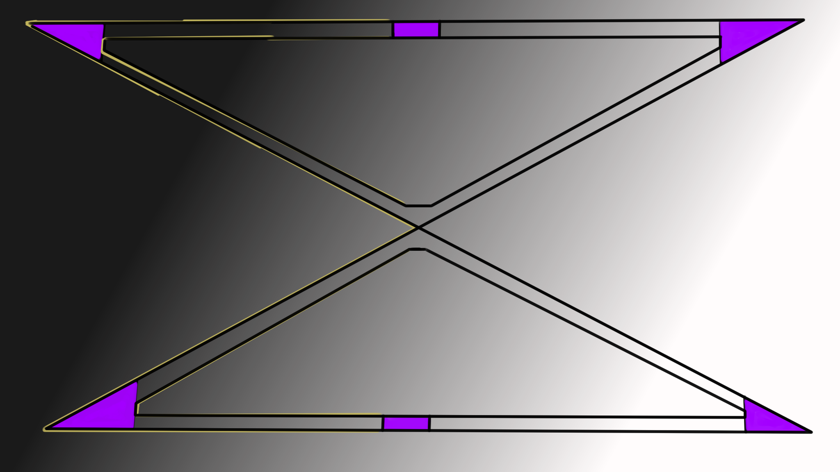

The players will start from their perspective “right” point. A full round will go around the triangle squares and end where the players began for a full loop. Once both teams are back at the “Start” the game round will end and then proceed to the next round.

The movement grid will have event spots to land on -- such as points where either team will accrue an amount of points for purely landing on it. For example, the Dark Team can land on a spot that nets them light points which is detrimental but can also land on a spot that nets them a reduction into negative points.

The corner spots are for event cards, if the player lands on it -- and likely two more spots on their respective board. It will incur an event card. If the player matches each other's respective spot on the board. This technically means that the opposing teams have “met” each other in some way. Gameplay will suit as follows: Blah, blah.

Outside of event card spots, there is also one respective karma battle spot on the board. IF both teams land on that spot -- there will be a battle of die rolls to see who can occur the most negative or positive karma in a specific amount of rolls.

This might mean there are two point systems -- one for scoring and one for karma. Rolls gained from battles will then be converted into karma. I’m thinking of a system that could work based on skills. However, I do not have much knowledge when it comes to board games that I must correct.

## Scenarios & Primers

The primer/scenario is a situation that the next events selected will be based on. The primer has five levels. At its lowest, it’s light but at its highest level it’s fully darked. The primer is what the initial event the game is based on is. Smaller primers are scenarios which can be twisted together.

During the start of a round, the player must choose a scenario card-- this will be the character who lost the coin toss. Ultimately the point of the game is also to fill-in the blanks. The Lingering Dread primer has no definite meaning. Although it should invoke the feeling of dread or being ominous.

Not all primers are ominous or bad -- they can be good, but manipulated into being neutral or bad. Likewise with the other primers.

Scenarios:

These are something that is selected at the beginning of a round, it should determine the pace and what all happens as well influence how the players will react to the rules. For example, The Primer is a scenario that begets the initial phases.

| **#** | **CARD TITLE** | **GENERIC DESCRIPTION** | **ALIGN** |
| --- | --- | --- | --- |
| 1 | The Lingering Dread | There is something odd at work, you can’t quite figure out what but it's disturbing you. | Neutral |
| 2 | Whales Washed Ashore | There have been a couple of odd whale sightings, the people aren’t sure what to think about it-- an omen, perhaps? | Bad |
| 3 | An Odd Family | There is an odd family that is around these parts, people have looked towards them for the source of their problems. | Neutral |
| 4 | A Wooded Mystery | There has been a mysterious sighting in the woods; you’ve gone to investigate. | Neutral |
| 5 | A Gargoyle in City | There are reports of a gargoyle in the city; whether it's true or not remains a mystery. | Neutral |
| 6 | Hospital Receives Donation | The local hospital has received a lofty sum in donation. You wonder why... | Good |
| 7 | A Job Offer | You’ve received a job offer from a person. | Neutral |
| 8 | Mystery Nurse | The nurse at the local hospital you’ve been volunteering for has been acting a bit shiftier, you aren’t quite sure but you’re curious... | Neutral |
| 9 | Exhumed Corpse | You’ve unearthed a corpse on the property. | Neutral |
| 10 | A Meeting To Die For | Someone who considers themself a killer-- wants to meet. | Bad |
| 11 | Strange Photos | You meet someone and a photo drops from their briefcase, as you’ve seen it. They’ve gone away. | Neutral |
| 12 | On Death Row | You’ve found out that someone on your team, or maybe yourself, was scheduled for death row once. | Bad |
| 13 | An Abandoned Cottage | There is an abandoned cottage in the woods. | Neutral |
| 14 | Mysterious Artifact | There is an artifact that is being guarded by some people. | Neutral |
| 15 | Contract To Kill | You, or a person in your party, have received a contract to kill someone. | Bad |
| 16 | A Random Package | There is a random package… what’s in the box?! | Neutral |
| 17 | Crossed Journal | There is a journal with a list of crossed out names. | Bad |
| 18 | An Arcane Awakening | You, or someone in your party, has the ability to perform arcane feats. | Neutral |
| 19 | A Silky Surprise | There is a nest of spiders of gargantuan proportions. | Bad |
| 20 | A Miraculous Cure | Someone had been cured of their affiliations; once disabled but now abled. To a point... | Good |
| 21 | Cultist Meeting | You’ve received an invitation to visit the occult meeting you never knew you had. | Neutral |
| 22 | Growing Death | There seems to be a growing “undead” problem. | Bad |
| 23 | Alphabet Agency | An occult-tracking alphabet agency has caught wind of your activities. | Neutral |
| ? | ?????????? | OCCUTSTUDIESAREINTHEWORKSPLEASEBE CALM | ?????? |
| ? | ?????????? | OCCUTSTUDIESAREINTHEWORKSPLEASEBE CALM | ?????? |

### Locations:

Locations are not specific to the primers however, they do help gear the story. Locations are designated as start and end points. These are supposed to be experimental. It might have an entry level which determines how hard or easy it is to break into the place if needed be. On a scale of 1 to 10. This should correlate with the experimental suspicion mechanic.

| **Locations** | **Location Description** |
| --- | --- |
| Warehouse | A derelict warehouse. |
| Hospital | An average hospital. |
| Waffle Emporium | A local chain restaurant that sells hotcakes, waffles and hash browns. |
| The Forest | A wide-spanning forest. |
| Plantation House | An old plantation house that has stood against the testaments of time. |
| Sanatorium | People used to be sent there to be treated for tuberculosis or in hospice care. |
| Parking Lot | A liminal space where cars come and go. |
| Convenience / General Store | An average place to go procure goods. |
| Sewers | Sewers-- it might lead to a hidden place, or just shit. |
| Church | Some people get sermons here, and others just drown. |
| Swamplands | A vast land filled with water, mosquitoes and trees with large roots. |
| Bunker | An old bunker that might have been recently used. |
| A Cave | Caves are usually considered gateways of sorts. |
| Government Building | A normal place of society filled with bureaucracy and spying. |
| Auto Mechanic / Mechanic Shop | Get mechanized things fixed, or appraised. |
| Supermarket | A place where you can get almost anything. |
| Campsite | A place to roast hot dogs and eat baked beans in the fright of nature. |
| Trainstation | A place to get to and from places; don’t play in the tracks. |
| Abandoned Building | A random derelict building. |
| School | Whether an elementary or a college, there’s something weird about them at night. |
| Prison | A palace of indentured servitude. |
| Police Station | Where reports are written and specific things are also dismissed. |

The location entry level should be akin to a PnP dexterity check. If for whatever reason the architect has the players arrive at night and they need to enter a locked area. The entry level difficulty should be accounted for.

## 

## Karma Points

An explanation of the Karma System that this game concept is geared around. The Karma Point System will have a Minimum and a Maximum Threshold. For example, the amount of points can be - a max of 250 and a min to -250 with the Neutral Threshold being between -50 and 50. It’s effectively a tug of war.

### Point System

The baseline points in the game that are accounted for after the end of each round are Karma Points. The point is to have it within the negative or positive threshold -- not the neutral threshold. If the amount of points remains neutral at the end of the round. It will end in a draw. After the start of each round, the player will be able to --- hm?

### Karma Tiers

To perform specific feats, the player teams will need to attain specific amounts of karmic points. The first tiers are essentially free to choose. Karma might be deducted depending on the feat level that is performed.

Tiers Tier Description

| I | These are common good and bad choices. There is no karma point requirement. |
| --- | --- |
| II | These are uncommon good and bad decisions; these have a karma point requirement. |
| III | Tier-III choices require having a Lesser Archangel or Lord of Hell card. There is no karma point requirement. |
| IV | Tier-IV choices require having a Lesser Archangel or Lord of Hell card as well as meeting a karma point requirement. |
| V | The final tier choices require having at least two Lesser or Archangel cards. |

## 

## 

## Event Cards

These should act primarily as catalysts or a wrench thrown in plans. Events cards come in black, white or grey. Unlike the primers, they are very specific and to the point which that’s it about. They are chance cards. They are not specific to a team. The Light team can get a black card for example, below are examples of intended title, descriptions and effects.

Black Cards

* These are more evil-aligned chance cards.

| **Title** | **Description** | **Effect** |
| --- | --- | --- |
| Dark Bidding | Shadowy and skullduggery deals have been created- for what purpose? | Increased Negative Karma Gain |
| A Bloodstained Gun | A bloodstained gun has been found in your possessions. You don’t remember... | Negative Karma Bonus |

White Cards

* Light-aligned chance cards.

| **Title** | **Description** | **Effect** |
| --- | --- | --- |
| Guided in Love | You have attracted the attention of an angel. | Increased Positive Karma Gain |
| Good Deeds | A good deed hasn’t gone unnoticed, relish in the good vibes. | Positive Karma Bonus |

Grey Cards

* These are more opportunistic cards that allow for chance encounters.

| **Title** | **Description** | **Effect** |
| --- | --- | --- |
| Momentary Setback | Karma gain is set to neutral. | Set Karma to Neutral |
| A Wishing Well | You’ve wished for guidance. | Pick another event card. |
| Set The Pace | Move forward… or take a few steps back. | Roll a 1-5 roll for movement. |

## Report Summary

The report summary is a way for keeping track of what goes on and what is happening in a round / game. The parts of the report summary are:

* Architect Name: The name of the person who is the architect.
* DOA - Date of Authorization, date of when the game’s first round has begun.
* Team - Record of members who are on the light or dark side.
* Pointed Earned - Karma Points earned by the respective light vs. dark teams per round.
* Primers Found - The specific primers that were utilized per round and scenario.
* Events Happened - Light, Dark and Grey cards that were utilized via going over event spots on the grid.
* Notable Happenings - Game centric things that happened that’s not apart of the general report.

## 

Link to [GB_ReportSummary](https://docs.google.com/document/d/1wvOQ9_4O4sqELOTBoBy40EwT7uTrVMUgTT3r5El2ju4/edit?usp=sharing)

## 

## 

## 

## 

## 

## 

## Flowchart(s) & Storyboards

Core Gameplay Loop:

## 

When the gameplay core loop goes through round three (or however many rounds wished to go through), the players will then end the match. Otherwise, after each round, a differing card will be chosen to go through.

Rules Visualization:

## Component Pieces

#### Cards

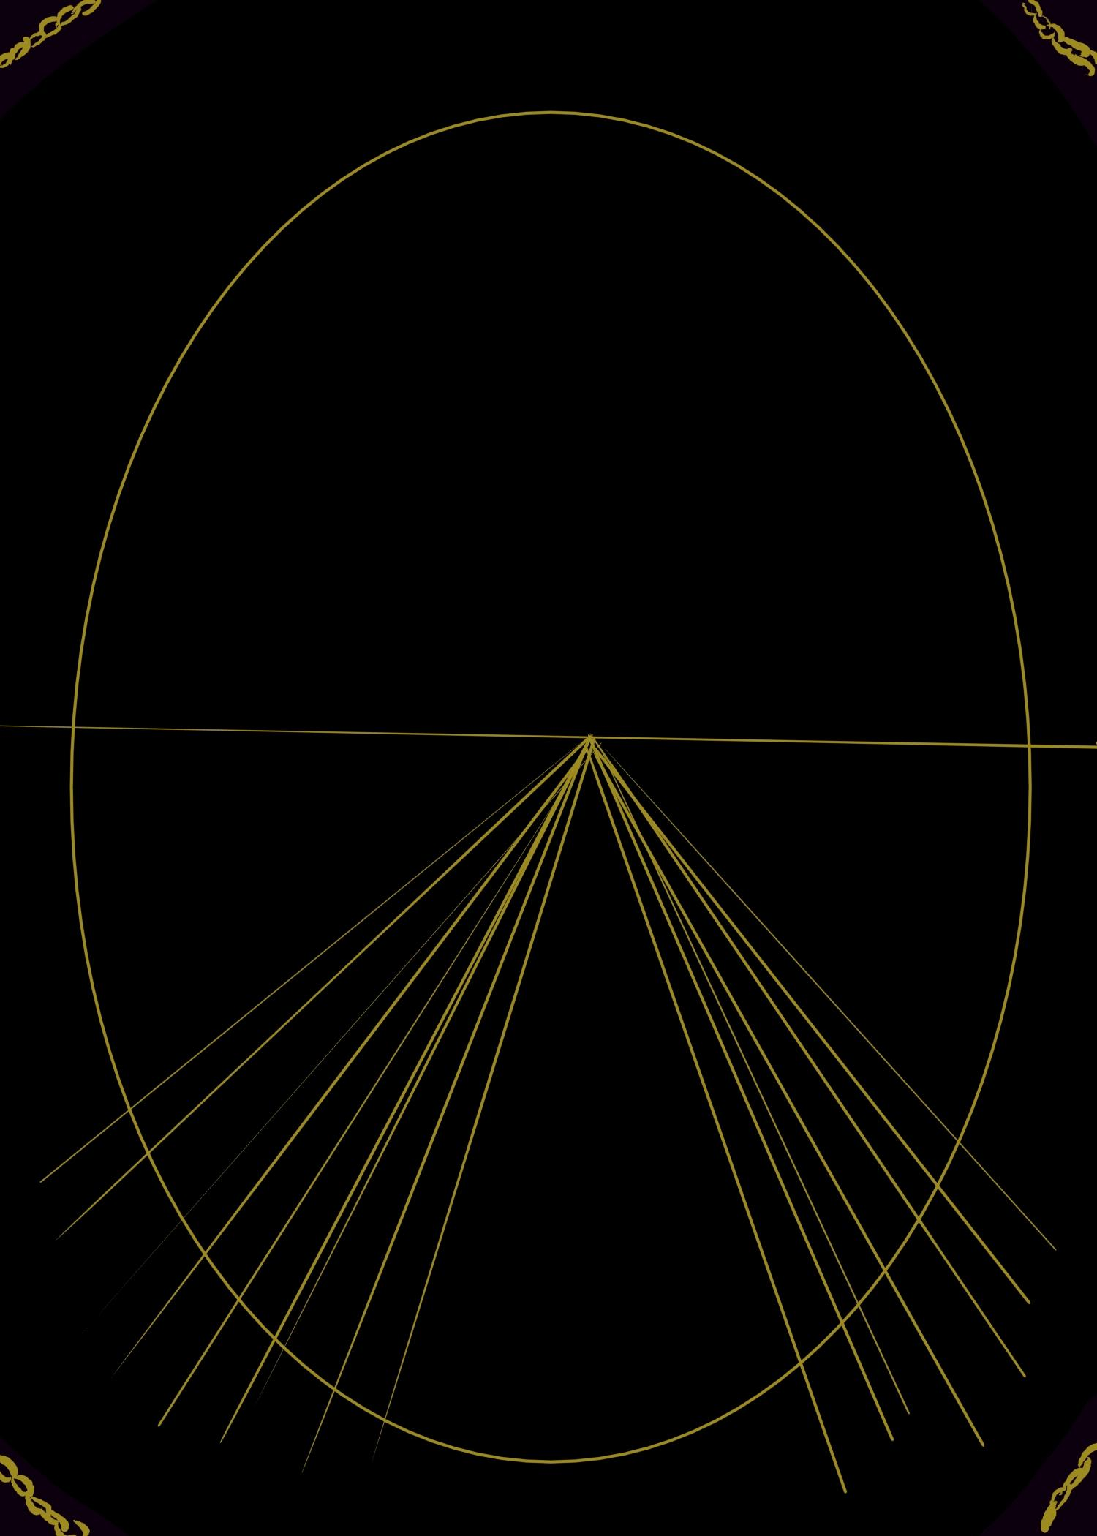

This is the back of the card.

The cards themselves should be seven lords and seven archangels -- so, drawing a specific card will have a boost to scenarios done in a later round. So, if a player gains a +1 GOOD NET, they will draw from the Archangel Deck, or lower deck for a card. So, if the opposing team has a Lord of Lust -- The Archangel of Temperance for example, will be a better card against it. Out of the seven, there will be one that is infinitely better than the others. However, it is weak against some lower tier opposites.

The front facing part of the card should be tarot-like in design but adhere to the overall color scheme. There should be a single chevron in the background for lower tiers, and two chevrons for Arch & Lords.

#### 

#### Items

The dice themselves; would be a special type of dice. The battle die! They are two five-sided dice. I’m thinking it would either be a five or seven-sided die. However, the total of two five sided-die is ten which would be -2; so 8 due to the effect symbols. Meaning rolling a +T would add a roll for the team or -T would negate a roll for the other team.

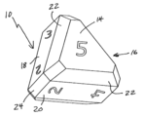

*(Image from:* [*https://patents.google.com/patent/US6926275*](https://patents.google.com/patent/US6926275) *by Louis J. Zocchi)*

Another is the standard six-sided die, with the same effects as the five-sided as described above. Except the total sum of both die would only be 10-- as the six would be removed. One more idea is a 12 sided die but only 10 numbers with instead two effects per die.

The starting coin will look like a challenge coin-- this could easily be replaced with a simple coin.

## 

## Other Ways to Play **(IGNORE THIS AND EVERYTHING BELOW)**

* Coins be used to to substitute cards-- Quarters being Lords and nickels being lessers.

Ideas for how the game progresses:

This has been the hardest part. Once I figured this out I can playtest and fine tune. This needs to be in a way that points can be obtained (or detract) and allocated. If there are tiers and the objective needs to be a side winning / or gaining enough points for a karma bomb (positive or negative) the core gameplay needs to follow suit.

My ideas so far are to:

* Discuss what should happen during scenarios
* Try to artificially gain more points during the scenario (like an auction)
* Have a thing as a ‘suspicion meter’ which would affect if a tier goes through or not

I have a feeling that the white and black (pos and neg) teams are going to need another point system to feed into the tiers -- which would be handwritten and/or typed scenarios with an assigned difficulty.

However, to not just make it a type of DnD thing it should be something needed.

Like…

A card that can be played during a scenario that could help one team or another. Like -- if someone placed a scenario that is to burn down the orphanages someone else on the team can have another card to supplement it. Or someone on an opposing team can play a card that could negate it. Which means there needs to be action cards of the same type --- that could ALSO have a luck meter.

The luck meter could be from 1 - 5 |&& whether or not it is the lowest or highest value can affect whether or not the karma gain or loss will succeed. This could be a 1 - 5 dice that needs to be rolled. So it might need a: 5 < 10 . as in the cards stat is a five and an angel or demon adds a +3; but the action card is a +4 which comes up to 9.. It needs to be over 10so the 9 could possibly earn a tie or a win. And gain karma (the card having a karma worth)

#### 

# Developers Log

2020/02/27

---------------------

It has been a long time since I last worked on this. This was first created circa 2019 around maybe… October?

2020/02/28

---------------------

There was a random moment where I got an idea about how the battles could go on via the dice. I added it into there including a picture of a patented five-sided die with the reference. On the actual board, I’m thinking the lines in between the triangle should be black, white and grey squares. The player will roll a movement die which is a single, regular die to go across for ‘one’ round. There will also be spots for random karma points.

Landing on a single black space might award negative karma; which if the team is light based and they have per se 260 karma. The negative karma will be a simple addition if it’s like… -20 Karma then the light based team will suffer a karma penalty. Because, Karma’s a bitch.

2020-04-24

---------------------

I’m wondering if, once a player goes around their board. Should they be granted a boon? And if so, should the first side (light or dark) only be granted to one who reaches back to the start from going around the board clockwise.

Also -- should the light go clockwise, and the dark go counter clockwise?

These are meaningful, but also thematic decisions for me to make as a designer.

2021-01-26

---------------------

I figured something out at least. Primers/Scenarios. These are something that is selected at the beginning of a round, it should determine the pace and what all happens as well influence how the players will react to the rules. For example, The Primer is a scenario that begets the initial phases. While the objective is still to win by obtaining an ArchAngel or a Lord of Hell.

I feel as if I should have some lesser attributes that could make black, neutral and white cards worthwhile for choosing or meaningful. Which is something like Luck. This influences the points attained by the end round Karma.

Suspicion should curtail how easy it is to do things in the inverse, there is trust. Either team, light or dark, can gain or lose either or. The tail end is Suspicion and to the far right is Trust on the meter.

2021-07-21

---------------------

I’ve literally not worked on this for several months. Alright, so the document itself has been reformatted and I’ve added a lot of better elaboration. With enough edits and additions, I’m hoping to start playtesting this to get a better idea of how it will go. The playtesting will focus on what exactly will make this fun to play and garner a general idea on that. The first few tests won’t be blind and then the next few ones may be.

The Karma Bomb (Gnosis Bomb) report summary is an in-lore document that should detail fictional adventures in a PnP RPG like setting. I might create an executable and/or web-based add-on component for testing this out since I realize that an issue will likely be materials. This will not track board movements but the overall gameplay concept.

I will be rebuilding the Dread Jam mechanics to work with this since I already have a template for a twenty-sided die written. This should be something easy to create. In a way… I’ve made the most significant progress now and I’m starting on creating the companion app for playtesting found:

<https://voidespy.itch.io/gnosis-helper>

This is a means to help make it accessible while also figuring out how specific things will work.’